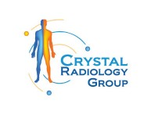The Role of Chest X-rays in Diagnosing Diseases at Crystal Radiology. (02) 8315 8292

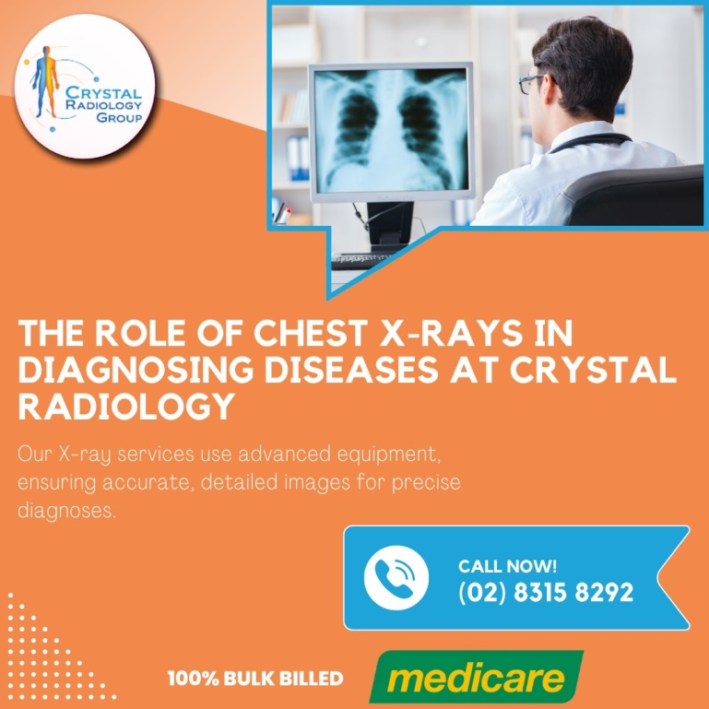Chest X-rays are a fundamental tool in medical diagnostics, providing essential images of the heart, lungs, blood vessels, airways, and the bones of the chest and spine. They are instrumental in diagnosing a range of conditions, from heart problems and lung infections to fractures and tumors. Let's explore the critical role chest X-rays play in diagnosing diseases and the numerous benefits they offer.

**Why is a Chest X-ray Done?**

Chest X-rays are among the most common imaging tests used by healthcare providers. They are often the first [diagnostic tool](https://crystalradiology.com.au/x-ray/) used when a patient presents with symptoms such as chest pain, shortness of breath, or a persistent cough. Here are some of the primary reasons a chest X-ray might be ordered:

**Heart-Related Lung Problems:** Chest X-rays can reveal changes in the lungs due to heart conditions. For example, congestive heart failure can cause fluid buildup in the lungs, which is easily detectable on an X-ray.

**Lung Condition:** X-rays can identify lung infections, cancer, or air around a lung that can cause it to collapse. They are also effective in [diagnosing chronic lung](https://crystalradiology.com.au/x-ray/) conditions like emphysema and cystic fibrosis.

**Heart Size and Shape:** An enlarged heart or changes in heart shape can indicate heart failure, fluid around the heart, or valve issues.

**Blood Vessels:** The main blood vessels near the heart are visible on a chest X-ray, helping to diagnose aortic aneurysms, other vessel issues, or congenital heart disease.

**Postoperative Monitoring:** After surgery on the heart, lungs, or esophagus, chest X-rays are used to monitor recovery and check for complications such as air leaks or fluid buildup.

**Calcium Deposits:** X-rays can detect calcium in the heart or [blood vessels](https://crystalradiology.com.au/x-ray/), indicating damage to the heart or presence of healed infections.

**Fractures:** They help in identifying fractures in the ribs or spine, providing crucial information for treatment.

**Medical Device Placement:** For patients with pacemakers, defibrillators, or catheters, X-rays ensure these devices are correctly positioned.

**When Do You Need a Chest X-ray?**

A chest X-ray is typically requested if you present with symptoms that may indicate chest or lung problems, such as:

* Chest pain
* Persistent cough
* [Fever](https://crystalradiology.com.au/x-ray/)
* Shortness of breath

These symptoms can be indicative of various conditions, from infections and lung diseases to heart problems and fractures.

**How to Prepare for a Chest X-ray**

Preparation for a chest X-ray is minimal:

**Procedure:** The X-ray is taken in a specialized room with a movable camera on a metal arm. You will be asked to stand next to a plate that either contains X-ray film or a sensor that [records images](https://crystalradiology.com.au/x-ray/) digitally.

**Positioning:** The technician will position you to capture both front and side views of your chest. You will need to hold your breath while the images are taken to ensure clarity.

**Painless Process:** The procedure is painless and quick, typically taking about 20 minutes. You may be asked to remove jewelry and wear a hospital gown.

**Understanding the Results**

A chest X-ray provides a black-and-white image of your internal structures. Denser areas, like bones and the heart, appear white, while air-filled spaces like the lungs appear darker.

**Bones:** Dense and appear white.

**Heart:** Appears as a lighter area.

**Lungs:** Air-filled and appear darker.

A radiologist will examine the images for signs of [heart failure, fluid](https://crystalradiology.com.au/x-ray/) around the heart, infections, malignancies, or other abnormalities. Your doctor will discuss the findings with you during a follow-up appointment.

**Conclusion**

Chest X-rays are a vital diagnostic tool in modern medicine. They offer a non-invasive, quick, and painless way to get detailed images of the heart, lungs, and chest bones, facilitating early diagnosis and effective treatment of various conditions.

**Why Choose Crystal Radiology?**

We are local and a Privately-owned medical Clinics that offers the highest quality medical and Imaging Services in the [Crystal region](https://crystalradiology.com.au/appointment/). We are the leaders in Bulk Billing with the real benefit of no ‘Out of Pocket’ expenses for you.

**Your Next Step**

Please ensure that you have your Medicare card and referral with you and pop into our location for your consultation. If you have any questions at all, please feel free to contact us on [(02) 8315 8292](https://crystalradiology.com.au/appointment/)  as we are here to help.